Contents
2.2B UK Support – Comparable Contract Evidence 2
A directly comparable and demanding service environment 2
Recorded response performance 3
A service that is improving, not standing still 4
Completion in one visit and controlled follow-on 5
Planned servicing across the mixed-brand estate 5
Independent Royal Navy customer feedback 6
How the evidence shapes the new agreement 6

2.2B UK Support – Comparable Contract Evidence
Tender Question: Provide evidence, in the form of example(s), that the Bidder can continually and consistently meet contracted lead times and deliver the UK service provision throughout the life of the contract.
Scoring Focus: One directly comparable contract within the last two years, comparable in size, scope and type, highlighting achieved performance.

COMPARABLE CONTRACT: Pulse Fitness’s existing Team Leidos/MOD service activity is directly comparable in customer, estate type, geography, equipment mix and operating model. The evidence below covers one aligned 24-month period—1 August 2024 to 31 July 2026—and demonstrates sustained planned and reactive delivery rather than a pilot or unrelated commercial example.

702 | 201 | 731 | 686
unique MOD cases | customer accounts/sites | recorded visits | cases with response data

A directly comparable and demanding service environment
The existing MOD workload provides stronger evidence than a case study from another sector because it reflects the same customer environment and the same operational challenges: geographically dispersed sites, unpredictable equipment failures, planned annual servicing, mixed manufacturers, access requirements and the need to maintain safe fitness provision for service personnel.
The case population contains 561 reactive repair or warranty requirements and 141 planned services. Warranty work forms the largest individual group, followed by Type A repair, Type B service, Type A service and Type B repair. This means the evidence is not dominated by predictable inspection activity; almost four-fifths of cases relate to live failures requiring diagnosis, parts and repair control.
The estate includes Wattbike, Technogym, Assault Fitness, Concept2, Pulse Fitness, Life Fitness, Matrix, Keiser, StairMaster and other manufacturers. Work covers treadmills, cycles, rowers, SkiErgs, strength, cable and functional equipment, consoles, sensors and control systems. That breadth is directly relevant to the new requirement.
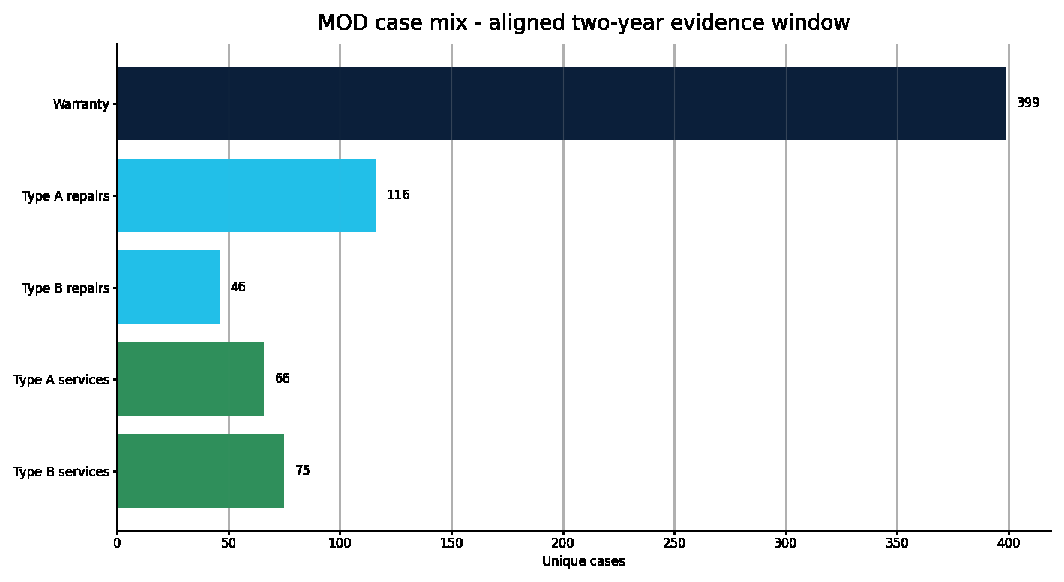
Figure 1 – MOD case mix within the aligned two-year evidence period.
What the figure shows: The chart shows 399 warranty cases, 116 Type A repairs, 46 Type B repairs, 66 Type A services and 75 Type B services. Together these total 702 unique cases.
Why it matters to the MOD: The mix demonstrates Pulse Fitness’s ability to sustain both planned and reactive delivery. The high proportion of live repair activity is a realistic test of engineer allocation, stock, technical support and customer communication.

Recorded response performance
Of the 702 unique cases, 686 contain a populated response value. The overall recorded average is 2.80 days and the median is three days. Across all recorded cases, 76.4% fall within three days, 87.2% within four days and 91.7% within five days. Reactive repair and warranty cases recorded a 2.68-day average and two-day median; Type B repair activity recorded a 2.36-day average, with 93.3% within three days and all within four days.
These results are described as recorded historic response rather than formal contractual SLA compliance. The legacy source field does not independently prove every contractual clock start, working-day treatment, customer delay or planned appointment rule. Pulse Fitness will measure the new agreement against the agreed purchase-order clock and priority definition, and will not treat supplier lead time as an automatic suspension of the SLA.
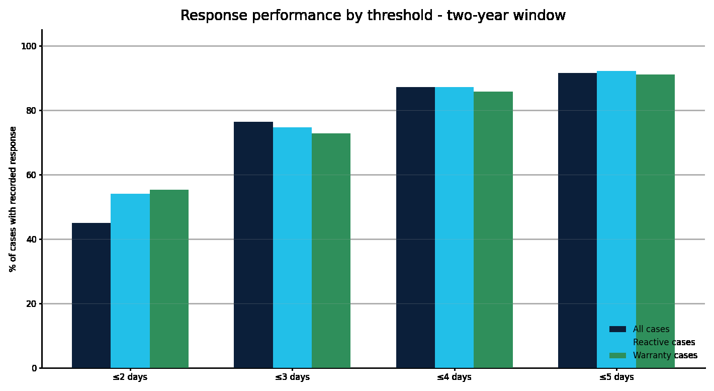
Figure 2 – Recorded response performance by threshold.
What the figure shows: The chart compares all recorded cases, reactive repair/warranty work and repair sub-types across the three-, four- and five-day thresholds.
Why it matters to the MOD: The distribution shows that delivery is consistently concentrated in the early part of the response window and is not dependent on one service type. The transparent boundary around the historic field protects the integrity of the claim.
Population | Average | Median | ≤3 days | ≤4 days | ≤5 days
All recorded cases | 2.80 | 3 | 76.4% | 87.2% | 91.7%
Reactive repair / warranty | 2.68 | 2 | 74.7% | 87.2% | 92.3%
Type B repair | 2.36 | 2 | 93.3% | 100.0% | 100.0%
Type A repair | 2.70 | 3 | 73.6% | 87.3% | 93.6%

A service that is improving, not standing still
The recorded average was 2.73 days for August to December 2024 and 2.66 days in 2026 year to date. The two-year trend includes a higher 2025 average, but the recent improvement demonstrates the value of stronger regional allocation, engineer preparation, parts control and active review of ageing work.
Pulse Fitness has not used the previously discussed 96.2% attendance figure as the principal historic KPI because the aligned case-level dataset provides the more recent and defensible audit trail above. This is a deliberate evidence-quality decision: the tender should be won on figures that can be explained and reproduced.
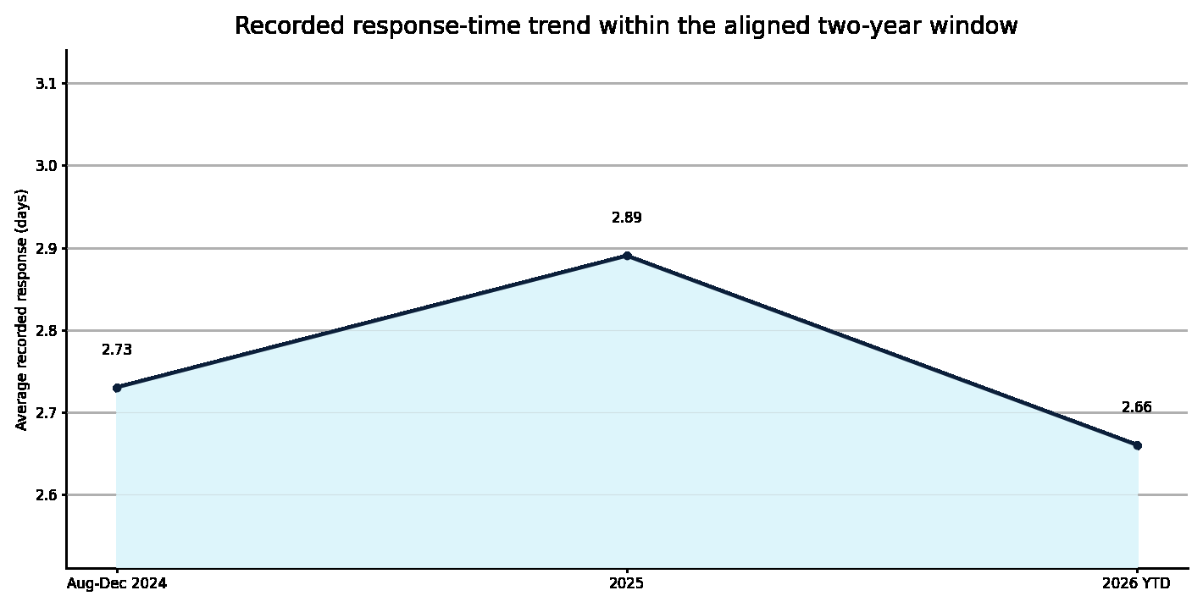
Figure 3 – Average recorded response trend within the aligned two-year window.
What the figure shows: The figure shows the partial 2024 period, full-year 2025 and 2026 year-to-date average recorded response.
Why it matters to the MOD: The latest result demonstrates operational improvement and provides a credible baseline for the enhanced controls proposed under LSL/DC/0223. Pulse Fitness will continue to use open-job, parts and regional data to drive further improvement.

Completion in one visit and controlled follow-on
Of 493 completed reactive cases with a recorded visit, 440 were completed in one distinct recorded visit. This gives an 89.2% single-visit completion proxy. The measure is intentionally not labelled as formal first-time fix because an agreed contractual definition would need to address parts, access, customer actions and repeat symptoms. Nevertheless, it provides useful evidence that most completed reactive work does not require multiple engineer attendances.
Where a return is needed, the data and job records show the practical controls behind it: the fault is diagnosed, the component is identified, the asset status is recorded and the follow-on remains open until the part and return attendance have been completed. That distinction matters because a responsible service provider should not force an unsafe or incomplete repair merely to protect a headline statistic.

Planned servicing across the mixed-brand estate
The 141 planned-service cases demonstrate the ability to organise inspection and maintenance across a dispersed estate while maintaining asset-level evidence. Recent examples include Type B servicing at RAF Brize Norton across Technogym and Life Fitness equipment, Type A servicing at RAF Benson with damaged and water-affected Concept2 screens identified for action, and a Type A service for The Royal Lancers where wear, noise and missing components were recorded with part references.
The outputs retained for this work include the engineer’s arrival and departure, service description, asset condition, serial number, customer and site, service type, parts or further action, service certificate, red label and countersignature. This evidence is what allows Pulse Fitness to demonstrate completion and give the MOD a reliable basis for follow-on decisions.

Independent Royal Navy customer feedback
The quantitative evidence is reinforced by direct feedback from MOD users who have experienced Pulse Fitness’s service and project delivery. Their comments describe the behaviours that are difficult to prove through spreadsheets alone: responsiveness, professionalism, communication, flexibility and the willingness to solve problems.
HMS NELSON AND THE SAIL LOFT – CPOPT RICHARD “CHAZ” CHARRETT BA (HONS): “We’ve consistently received excellent support from Pulse Fitness at HMS Nelson and the Sail Loft. The team has always been responsive, professional, and proactive when dealing with equipment issues, ensuring minimal disruption to our users. Communication is clear throughout, and the engineers are knowledgeable and approachable.”

The feedback also recognises Graham White’s professional support and states that Pulse Fitness’s reliability has helped maintain safe and effective fitness facilities for Royal Navy personnel.
HMS SULTAN – POPT JOE COLLIN: “During my tenure as a PTI and later as Office Manager at HMS Sultan, I can confidently say that working with Pulse Fitness on this project has been the best experience I have had to date.”

The HMS Sultan statement highlights Pulse Fitness’s ability to manage a significant project, accommodate additions and removals, hold stock while funding was released, deliver smoothly and on schedule and provide transparent multi-order and cost tracking. It concludes with an unqualified recommendation for future MOD PTE and support services.

How the evidence shapes the new agreement
The comparable contract has directly informed the proposed model. The mix of reactive work supports the investment in area-tailored van stock and central parts. The distribution of sites supports the regional-plus-national engineer structure. Repeat and parts-dependent activity supports the use of asset history and structured fault evidence in MODService. Customer feedback reinforces the value of one central account team that communicates clearly and remains flexible when MOD requirements change.
Pulse Fitness is therefore not proposing an untested operating theory. It is offering a controlled continuation and improvement of a service already delivered to the same customer across a substantial mixed-brand estate. The new plan adds clearer purchase-order and SIP controls, stronger portal visibility, enhanced asset evidence and a more explicit competence and resilience framework.

